Fiscal Year 2027 H-1B Lottery
The initial registration period for the fiscal year 2027 H-1B lottery is expected to start in early March 2026 and remain open for at least 14 calendar days. Learn more about what you can expect during the upcoming H-1B lottery season, including the introduction of a weighted selection process.

Registration Process and Fee
If an employer wants to apply for an H-1B visa for a foreign worker, there are a few steps to follow. First, employers and their attorneys need to create accounts on myUSCIS.gov to participate in this process. Then the employer must register electronically and pay a
$215 fee for each person being registered. This fee is nonrefundable and must be paid online through the pay.gov portal. It is separate from any other fees that might need to be paid later if the registration is selected in the H-1B lottery. If working with an attorney, the employer will need to coordinate electronically with the attorney.

Information required for registration includes:
- Employer’s name, employer identification number (FEIN), and address.
- Employer’s representative contact details.
- Employer’s attorney information.
- Foreign worker’s full name, date of birth, country of birth, country of citizenship, gender, and passport number.
- Whether the foreign worker has a master’s degree from a U.S. higher education institution.
- Foreign worker’s wage level information (wage level I, II, III or IV). Speak to your immigration attorney
to determine the appropriate wage level for each registrant.

Additional Considerations:
- USCIS may deny or revoke H-1B visas if the registration contains false information or if the registration fee is not properly paid.
- If selected, USCIS now permits a start date on or after October 1, as long as it is within 6 months of the petition filing.

Selection Process

Beneficiary-Centric Selection Process:
Each foreign worker will only have one chance in the lottery, even if multiple employers submit registrations on their behalf. USCIS will ensure that each registrant is only entered into the lottery once based on their passport information or travel document information.

Weighted Selection Process:
USCIS has finalized a new selection process for the fiscal year 2027 H-1B cap lottery. Under the new rules, the lottery would no longer be completely random. Instead, registrations for jobs with higher wage levels will have
a better chance of being selected than those with lower wage levels. The government groups salaries for each job and location into four wage levels, from lowest to highest. Wage level one is typically tied to entry level positions, while wage level four is for senior level positions. As a result, the salary offered for a position could affect the odds of being selected.

Note: This new weighted selection process will likely be challenged in court, which could delay or stop its implementation.


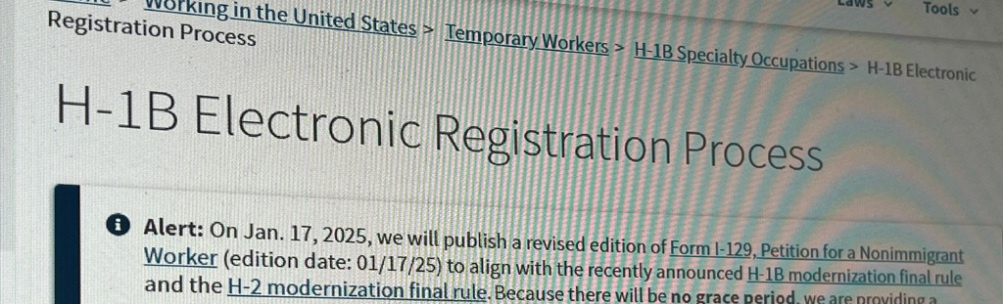
©2026 American Immigration Lawyers Association
Flyer last updated on January 26th, 2026.
AILA is the national bar association of immigration lawyers comprised of over 15,000 members located in every state of the United States and worldwide.
This flyer is intended for general information purposes only and does not constitute legal advice. You should not act or rely on any information in this flyer without seeking the advice of a competent, licensed immigration attorney. If you are a prospective client and would like to schedule a consultation with The Law Offices of Timothy D. Widman in Cupertino, California, please call (408) 366-2801.

