Current Status of DACA

Deferred Action for Childhood Arrivals (DACA) is a
U.S. immigration policy that provides recipients with employment authorization documents (EADs) and some protections against deportation. DACA is available for renewal for certain individuals who came to the United States as children and who are unlawfully present in the United States.
United States Citizenship and Immigration Services (USCIS)
is not currently processing first-time DACA applications.

However, individuals who already have DACA may:

Renew their DACA and employment authorization every two years
  - To qualify, individuals must:
    - Submit their renewal application between 120 and 150 days of their DACA expiration date;
    - Have continuously resided in the United States since June 15, 2007;
    - Not have departed the United States on or after August 15, 2012, without permission; and
    - Not have been convicted of a felony, a significant misdemeanor, or three or more misdemeanors, and not be a threat to national security or public safety.

NOTE
Certain types of employment authorization qualify for an automatic extension after filing a renewal application. This automatic extension does not apply to EADs based on DACA.

Apply for permission to travel internationally for
specific purposes
  - DACA recipients may receive permission to travel outside of the United States for educational, professional, or humanitarian purposes. Traveling outside of the United States, even with permission, can be legally risky for some individuals. Consult an immigration attorney before traveling.

Current Status of the DACA Program
  - USCIS is not currently accepting or processing initial DACA applications (for individuals eligible for DACA but who have not previously applied for this benefit).
  - USCIS continues to accept and process DACA renewal applications.
  - Although DACA is now a federal regulation, there is still ongoing litigation challenging the program. This includes the case Texas v. United States, which has not yet received a final decision. Once this case is decided, USCIS may be required to begin adjudicating initial DACA applications again, but with limitations for work authorization for Texas residents, including a proposal to code for deferred action and not lawful presence. The existing government shutdown affects the timeframe in which a final decision will be issued. We recommend applicants first speak to a qualified immigration attorney for additional updates on this case and to determine if applying is the right step for you.
  - Individuals who may wish to prepare to file first-time applications, once the case is decided, may to begin to prepare by collecting the necessary documentation.


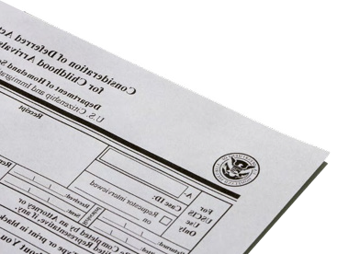
This flyer is intended for general information purposes only and does not constitute legal advice. You should not act or rely on any information in this flyer without
seeking the advice of a competent, licensed immigration attorney.

If you have questions regarding your case or DACA eligibility,
we encourage you to contact the Law Offices of Timothy D. Widman, a boutique immigration law firm based in Cupertino, California, at (408) 366-2801

